

**Cinema Seats Booking App**

**Faculty:**

Mr. Muhammad Idham Khalif, S.Kom

Arranged by : Group 4

|  |  |
| --- | --- |
| 1. Gafrilatif Aviandi Putra Adnanta | (2120010053) |
| 2. Muhamad Farhan Budiana | (2120010203) |

**Continuing Education Program Center for Computing and Information Technology Faculty of Engineering, University of Indonesia**

**2023**

**PROJECT ON**

**Movie Cinema Seats Booking App**

Page 3

Batch Code : 4 ISA 2

Start Date : 2 April 2023

End Date : 17 April 2023

Name of Faculty : Muhammad Idham Khalif, S.Kom

**Group 4**

* 1. Gafrilatif Aviandi Putra Adnanta (2120010053)
* 2. Muhamad Farhan Budiana (2120010203)

This is to certify the report, titled **Movie Cinema Seats Booking App** embodies original work done by Gafrilatif Aviandi Putra Adnanta and Muhamad Farhan Budiana in fulfilling the first Java using Netbeans IDE project assignment in CCIT-FT UI.

Coordinator

Mr. Muhammad Idham Khalif, S.Kom

**CERTIFICATE**

**ACKNOWLEDGEMENT**

Praise be to the presence of Allah, SWT. who has helped us in making this project because without the pleasure of it we will not be able to make this project. we also thank to Mr. Muhammad Idham Khalif, S.Kom as our lecturer and mentor in making this project entitled **Movie Cinema Seats Booking App.**

The success and final outcome of this project required a lot of guidance and assistance from many people and we were extremely privileged to have got this all along the completion of our project. All that we have done is only due to such supervision and assistance and we would not forget to thank them. Hopefully what we have made can be useful in the future.

Best Regards,

**Authors**



A system analysis of a movie cinema seats booking app using Java that uses Phpmyadmin database involves identifying the functional and non-functional requirements of the system, such as features for browsing movies, reserving seats, and purchasing tickets.

Movie cinema seats booking app using Java and Phpmyadmin database is a complex system that requires careful analysis to ensure it meets the needs of its users. Through system analysis, we can identify the functional and non-functional requirements of the app, such as features for reserving seats, purchasing tickets, login username and password, registered new account , usability, and performance. By considering these requirements, we can design and develop a reliable system that provides an enjoyable experience for user.

**System Analysis**

**Database Design**

Database design for creating a new account and login for an existing account.

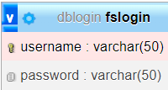

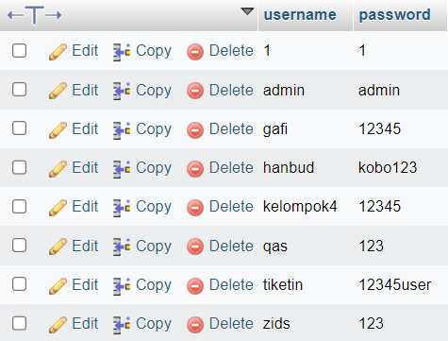

**Database Design**

Database design for Studio 1 : Spiderman No Way Home seats.

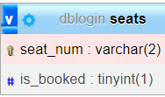

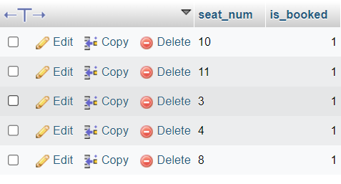

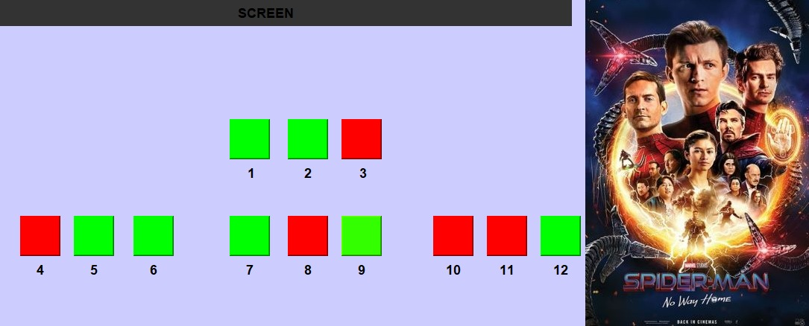

**Database Design**

Database design for Studio 2 : Suzume no Tojimari

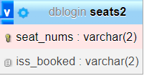

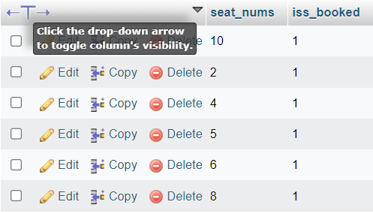

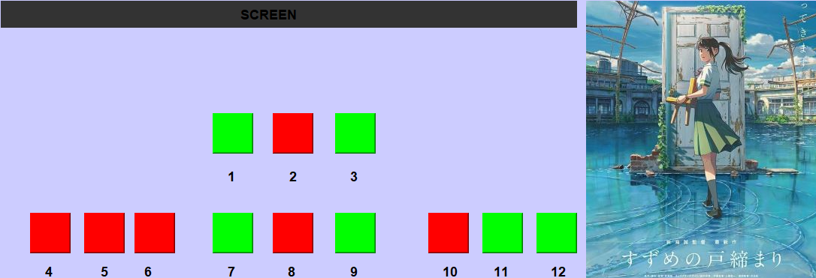

**Database Design**

Database design for Studio 3 : Fast 9 Saga

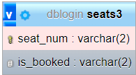

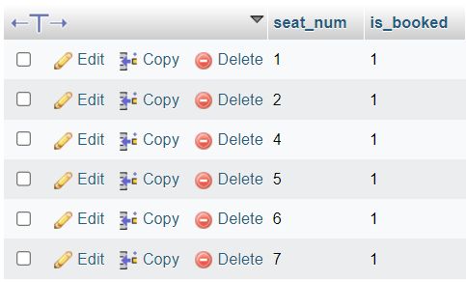

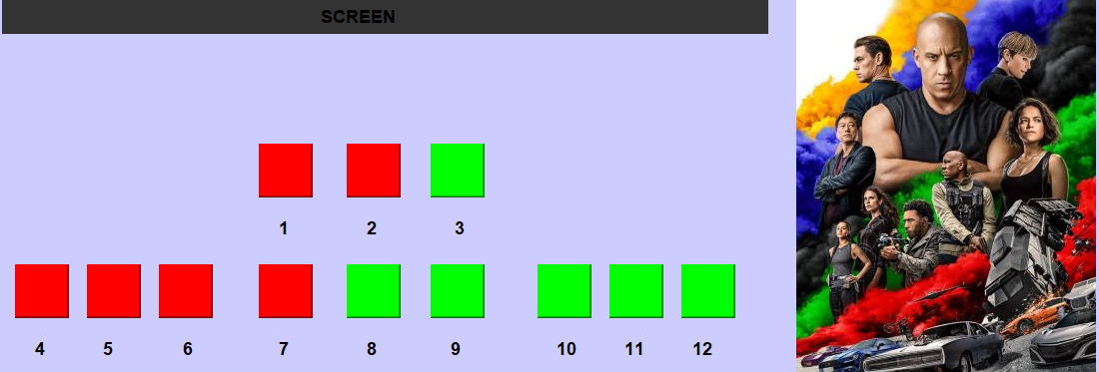

**User Interface (UI)**

Login form page, there is two (2) button including;

Existing Acc = Created account that already stored and saved on Database phpmyadmin.

Register = Creating new account and then saved it into database.



Notification that successfully connected to the database.

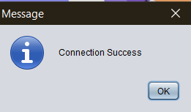

**User Interface (UI)**

Page that functions to enter existing and newly created accounts

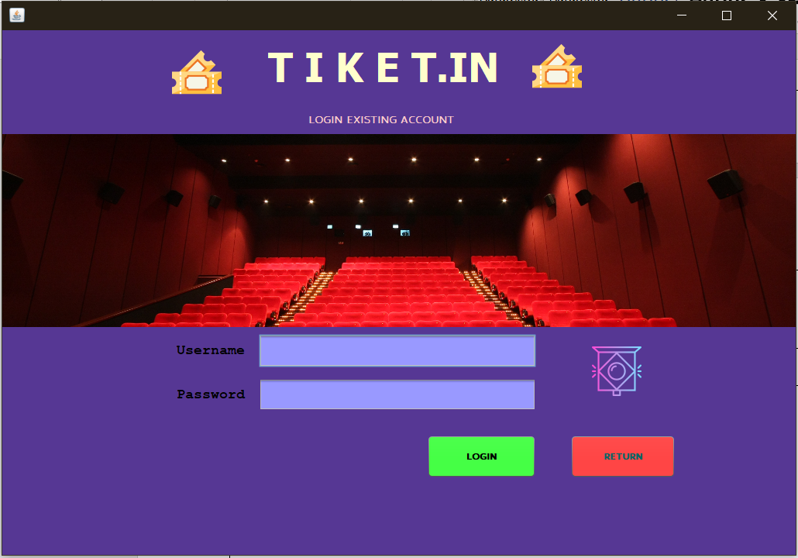

Page to select the movie that the user wants to watch

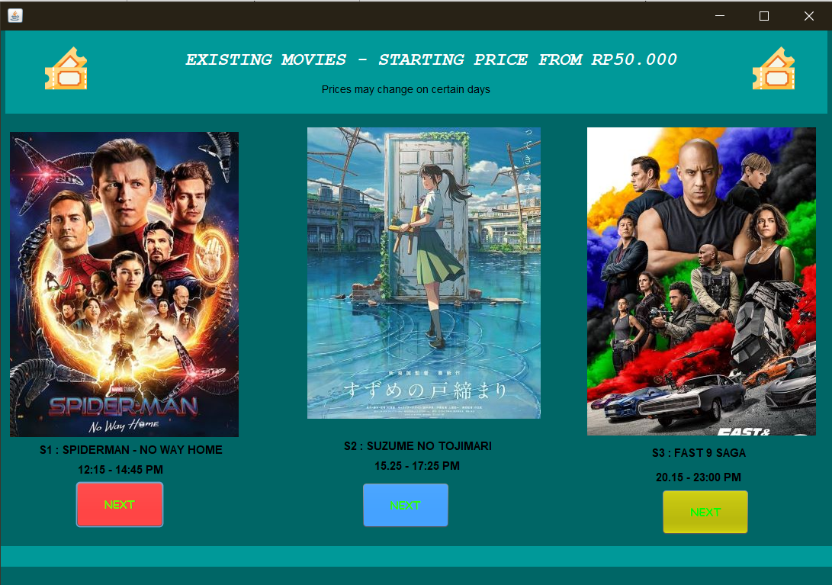

**User Interface (UI)**

Page that show Studio 1 available and booked seats.

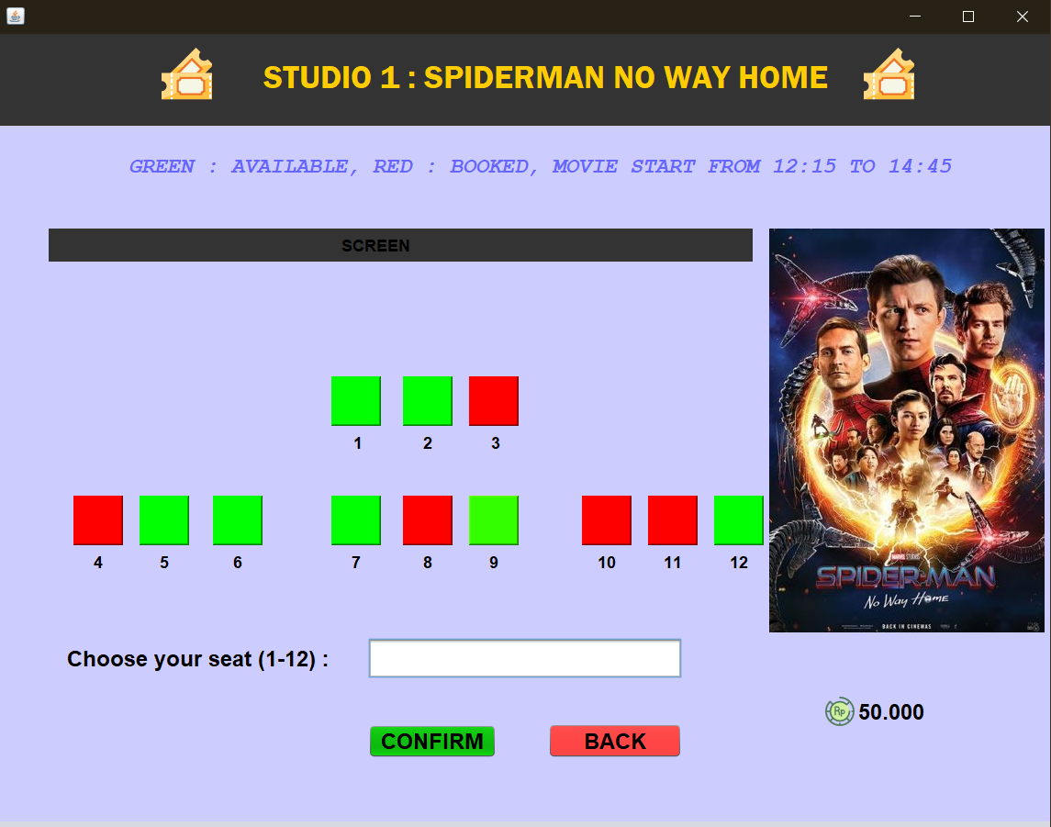

Page that show Studio 2 available and booked seats.

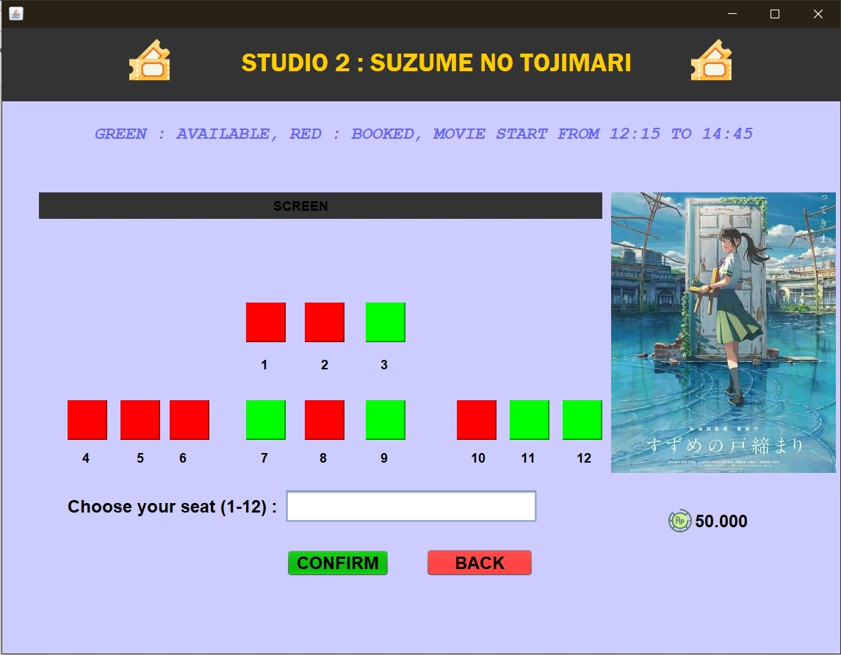

**User Interface (UI)**

Page that show Studio 3 available and booked seats.

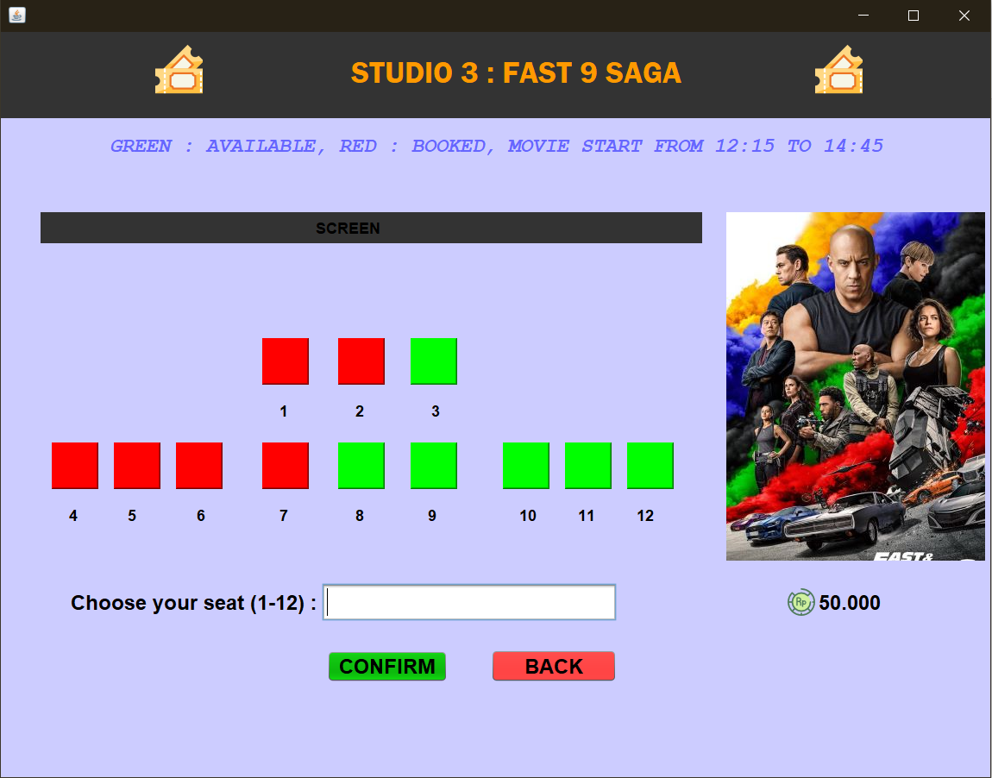

Payment confirmation page

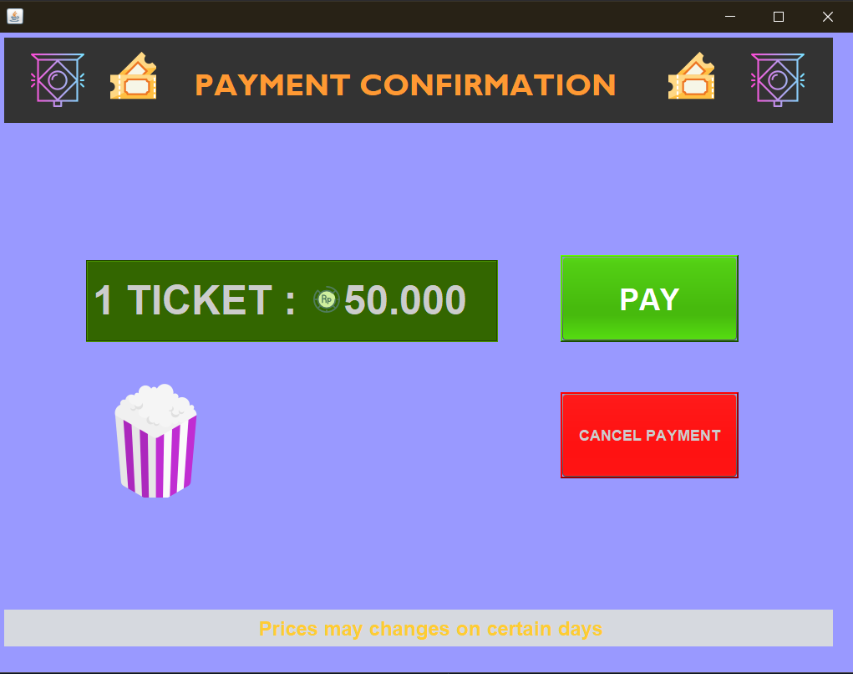

**User Interface (UI)**

Last page with main menu

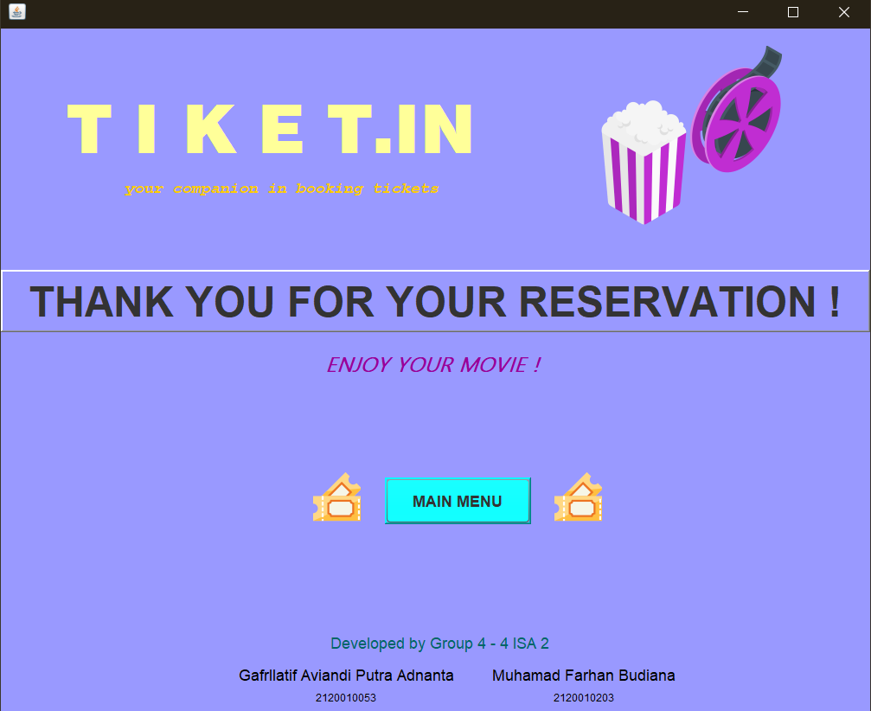

**Configuration**

Hardware :

HP Omen 15

Lenovo Legion 5

Operating System :

Windows 10 Home Single Language

Software :

Netbeans IDE 8.2

XAMPP Control Panel

Microsoft Word 2016

Figma

|  |  |  |
| --- | --- | --- |
|  | PROJECT FILE DETAILS |  |
| NO | File Name | Remarks |
| 1 | Movie Cinema Seats Booking App.docx | Microsoft word contains paper of this project |
| 2 | Movie Cinema seats Booking App presentation.pdf | Figma Presentation |
| 3 | Tiketin Project.zip | ZIP file that contains of the program of our project |